**Raymond You and Andrew Whitaker**

**EECE 2160 8am - Kimani**

**Lab 6**

**Assignment 1**

b)

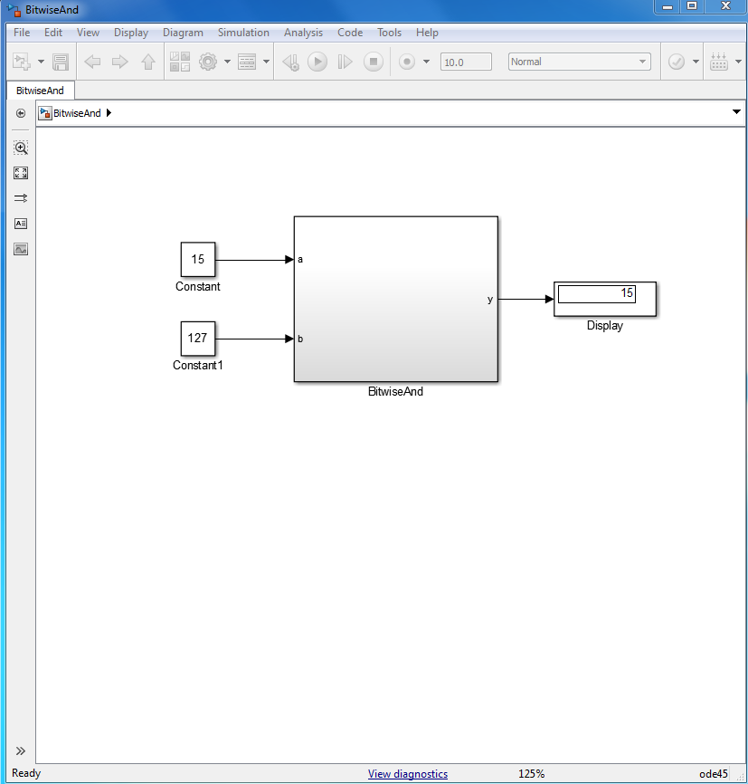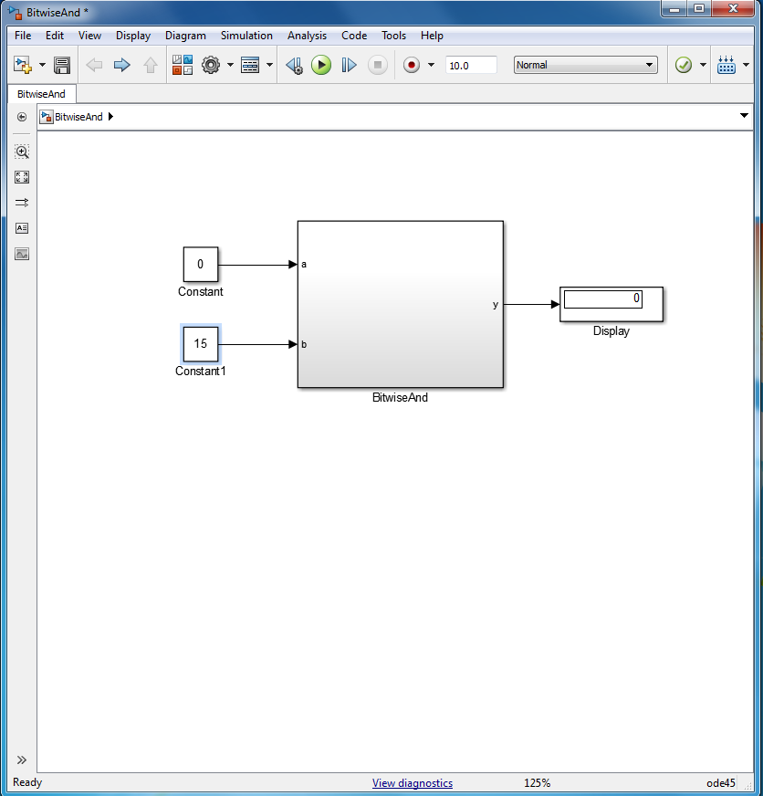

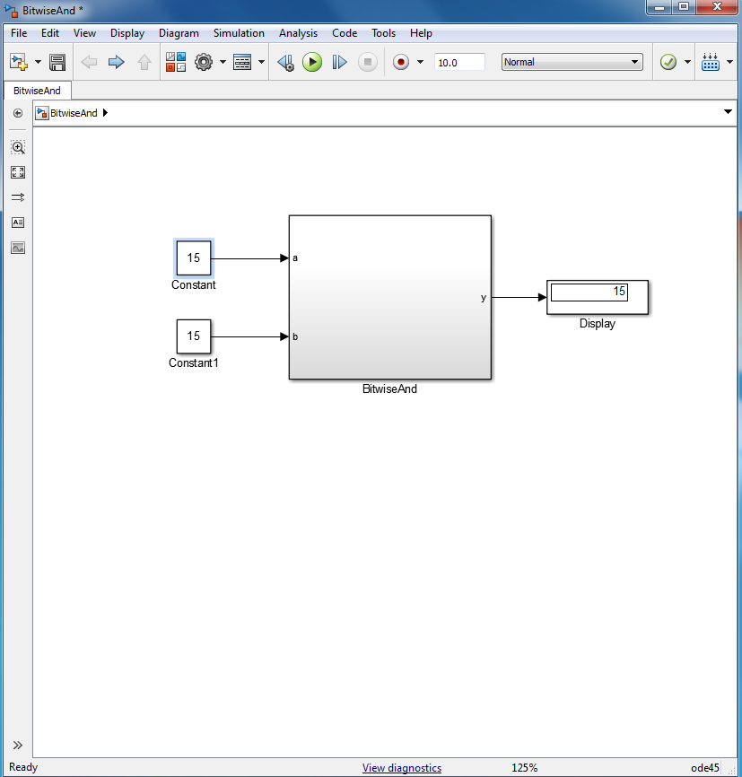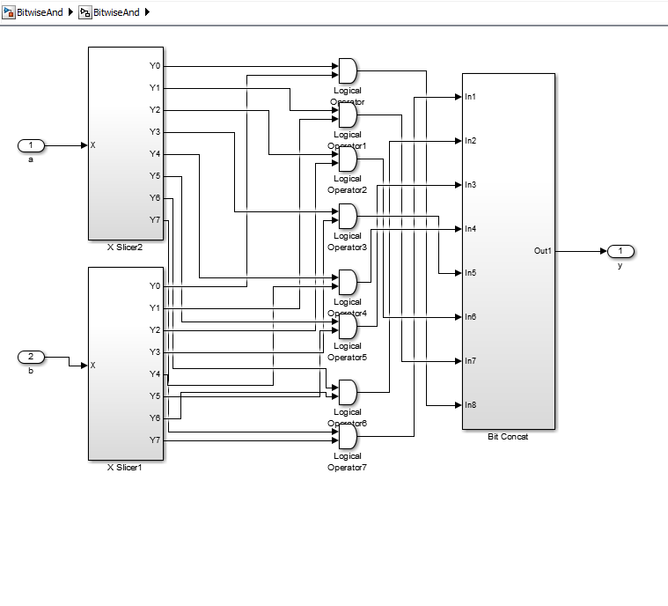

**Assignment 2**

b)

|  |  |  |
| --- | --- | --- |
| C1 | C2 | Result |
| 0 | 0 | I1 |
| 0 | 1 | I2 |
| 1 | 0 | I3 |
| 1 | 1 | I4 |

The selector input is 00, thus l1 is selected; l1 is 0 and 0 is outputted.

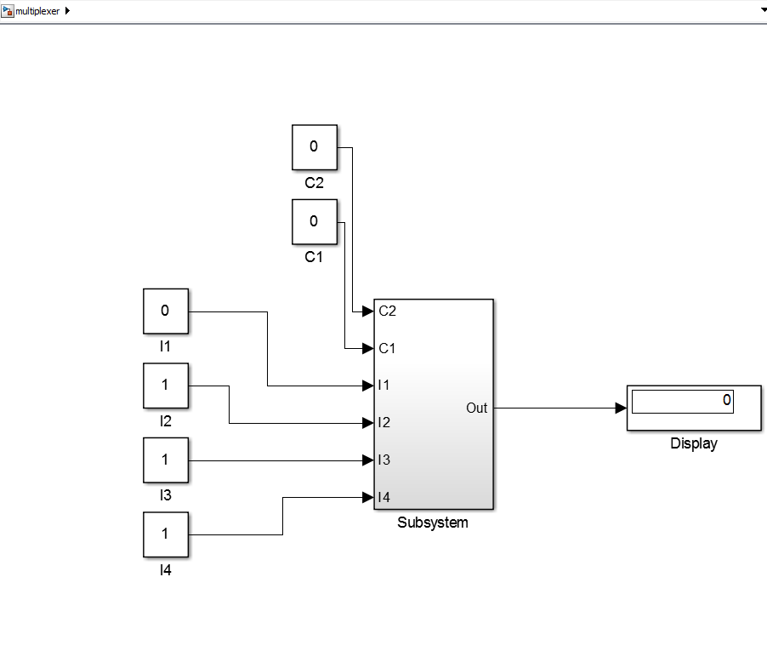

The selector input is 01, thus l2 is selected; l1 is 1 and 1 is outputted.

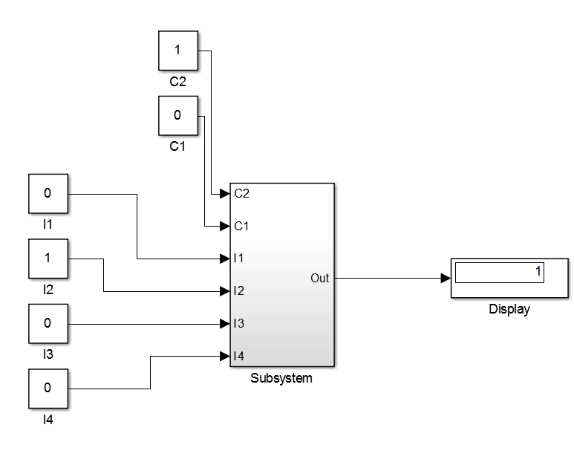

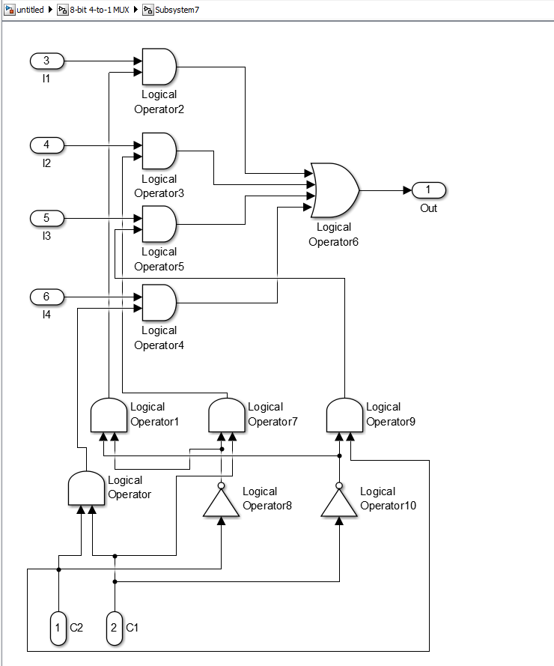

**Assignment 3**

b)

The selector input is 0, thus input 0 is selected; input 0 is 255 and 255 is outputted.

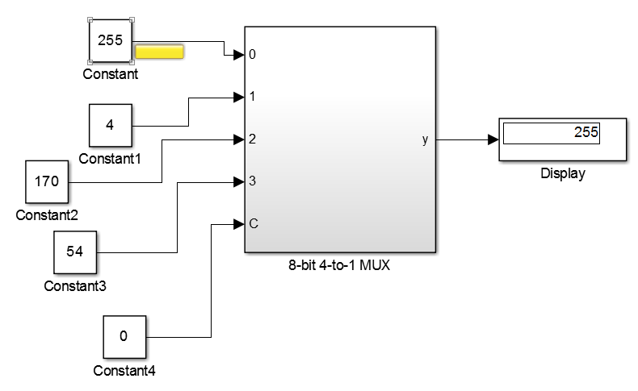

The selector input is 1, thus input 1 is selected; input 0 is 4 and 4 is outputted.

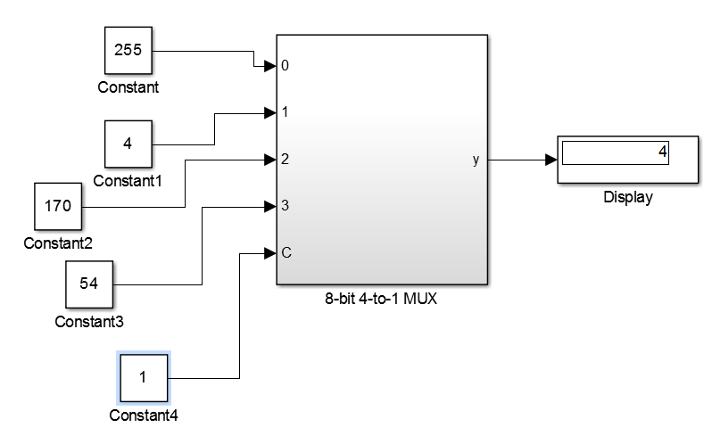

The selector input is 2, thus input 2 is selected; input 2 is 170 and 170 is outputted.

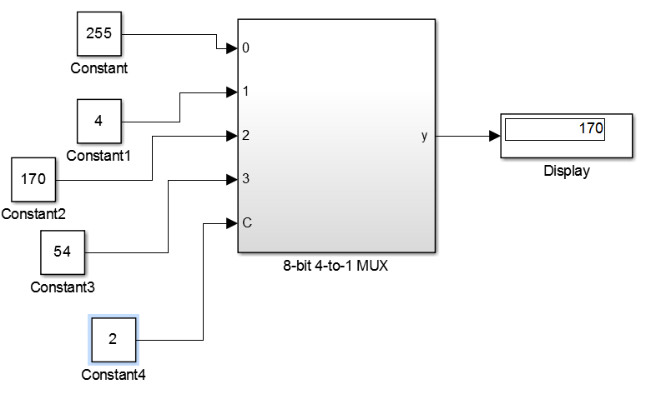

The selector input is 3, thus input 3 is selected; input 3 is 54 and 54 is outputted.

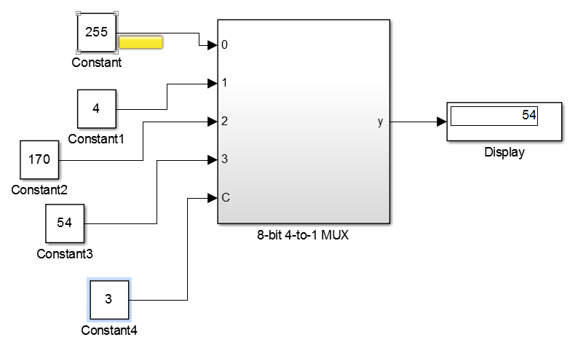

**Assignment 4**

b)

Addition

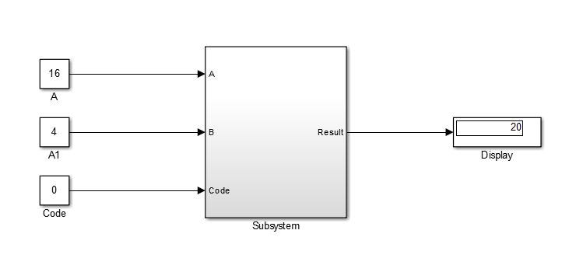

Subtraction

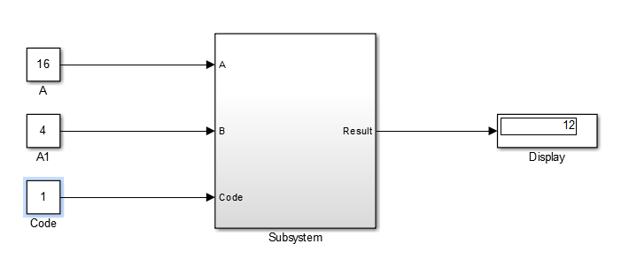

Multiplication

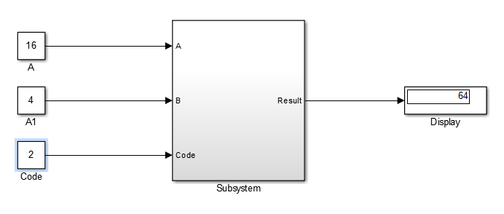

Bitwise “AND” operation

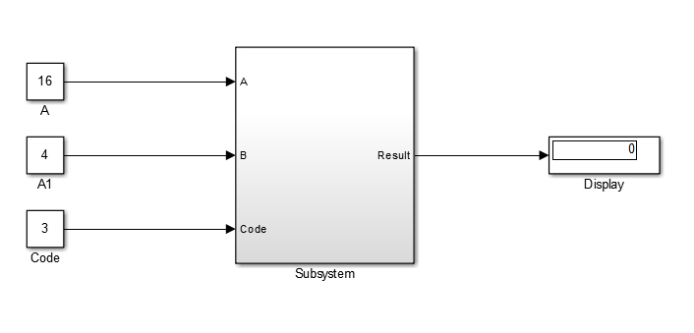

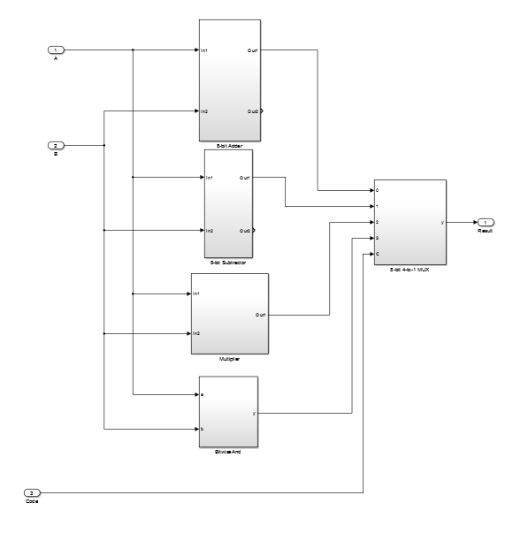

**Assignment 5**

a)

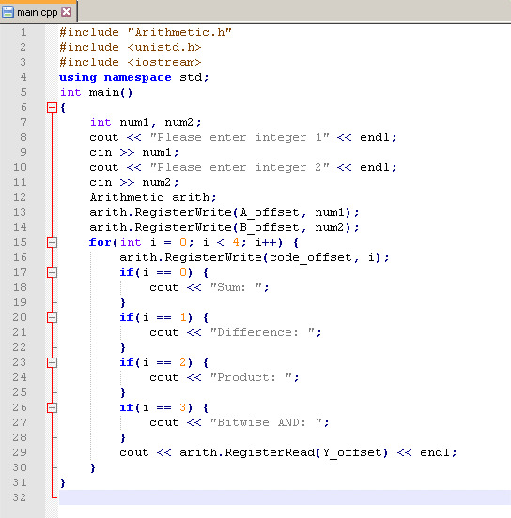

b)

